**DEPARTMENT OF MECHANICAL ENGINEERING  
  
Subject: Fundamentals of Programming  
Assignment No. 1  
Submitted by: Muhammad Maaz  
Registration number: 479510  
Semester No. 1  
Date: October 11, 2023**

**FIRST PROGRAM**

#include <iostream>

using namespace std;

int main(){

int n,f=1;

cout<<"Enter a number for factorial calculation: ";

cin>>n;

for(int i = n;i>=1;i--)

{

f=f*i;

}

cout<<"factorial of "<<n<<" is : "<<f;

return 0;

}

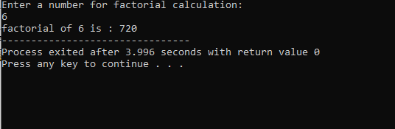

**SECOND PROGRAM**

#include <iostream>

#include <cmath>

using namespace std;

int main (){

int x1,x2 ,y1,y2;

cout<<"Please enter values for x1 , x2, y1 and y2 respectively: "<<endl;

cin>>x1>>x2>>y1>>y2;

int d = pow ((x2-x1),2)+pow((y2-y1),2);

cout<<"THE DISTANCE BETWEEN POINTS IS"<<endl;

cout<<d;

return 0;

}

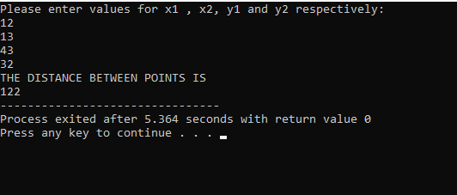

**THIRD PROGRAM**

#include <iostream>

using namespace std;

int main (){

int c, m, km;

cout<<"Enter value in cm: "<<endl;

cin>>c;

m = c/100;

km = m/1000;

cout<<"The value in meter is: "<<m<<" The value in kilo meter is: "<<km<<endl;

return 0;

}

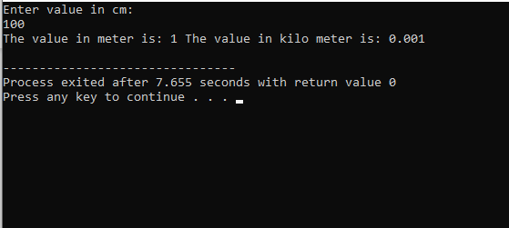

**FOUTH PROGRAM**

#include <iostream>

#include <cmath>

using namespace std;

int main (){

int a, b;

cout<<"Please enter value for a and b: "<<endl;

cin>>a>>b;

int p = pow(a,2)+2*a*b+pow(b,2);

cout<<"The polynomial formula is: "<<p;

return 0;

}

